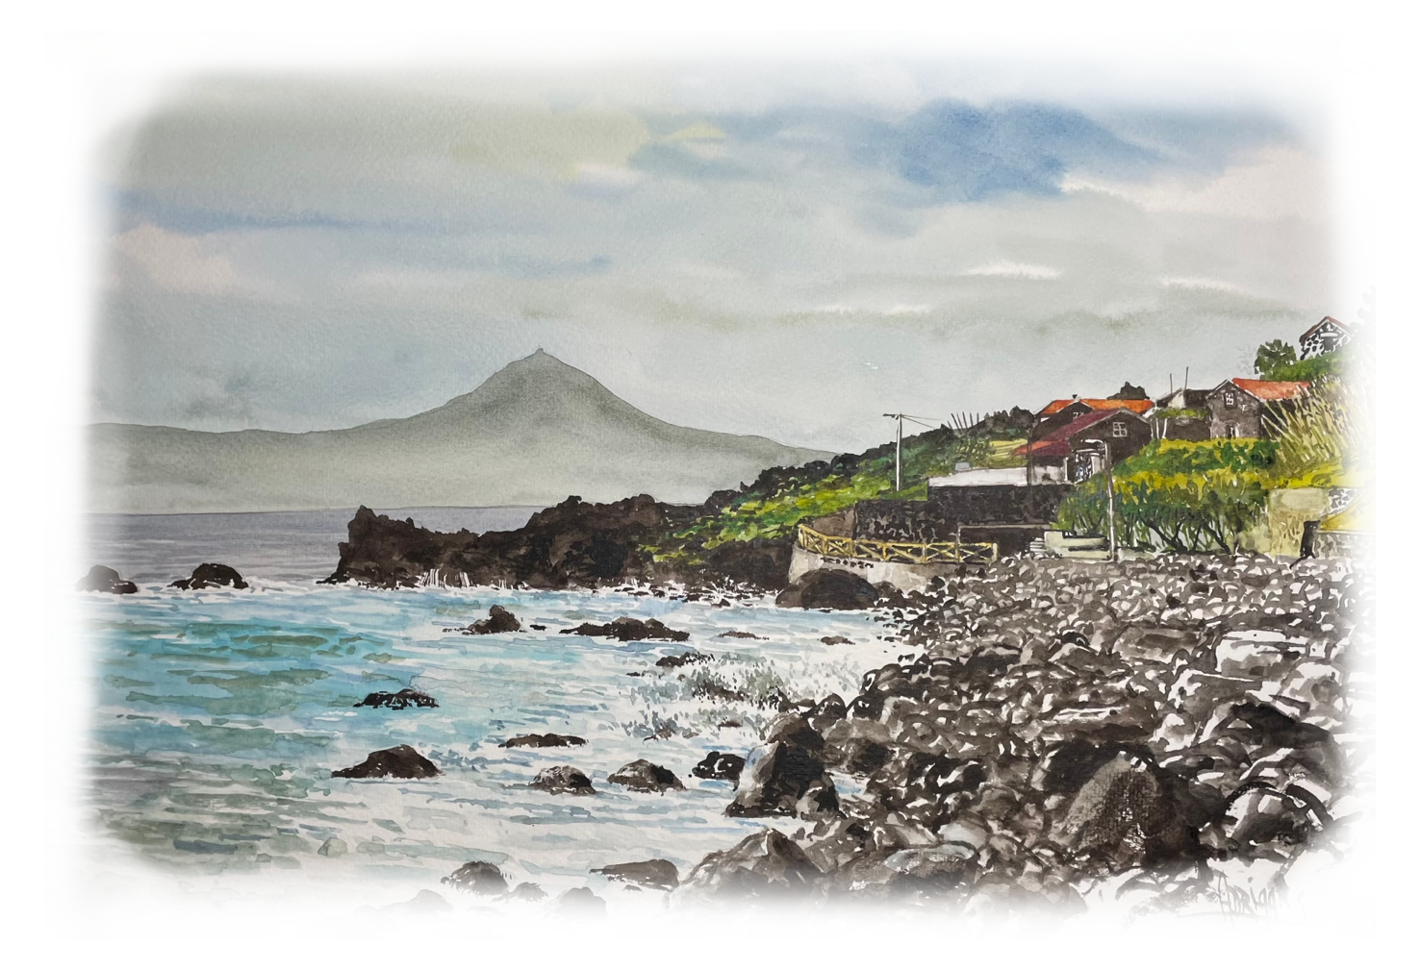
Specialties Menu

- Portion of Limpets à Manezinho (800gr) | 48.00€
- ½ Portion of Limpets à Manezinho(400gr) | 25.00€
- Codfish à Zé do Pipo  (Cod loin with onion sauce and tartar mayonnaise, on a bed of mashed white potatoes) | 27.00€
- Grouper Ceviche  (Fish marinated and served with lettuce, onion, and cherry tomato salad) | 17.00€
- Chicken Burger  (Bread, Thousand Island sauce, chicken fillet, onion marmalade, bacon, cheddar cheese, onion rings, pineapple and fries ) | 16.00€
- Duck Magret  (Duck breast on a bed of carrot purée with orange and citrus sauce) | 27.00€
- Octopus Salad  (Octopus pieces seasoned with a mix of peppers, cherry tomato, and onion) | 15.00€

